Daniel Meyer

CSE 420-01

Lab 1

Simple Draw

**Part 1:**

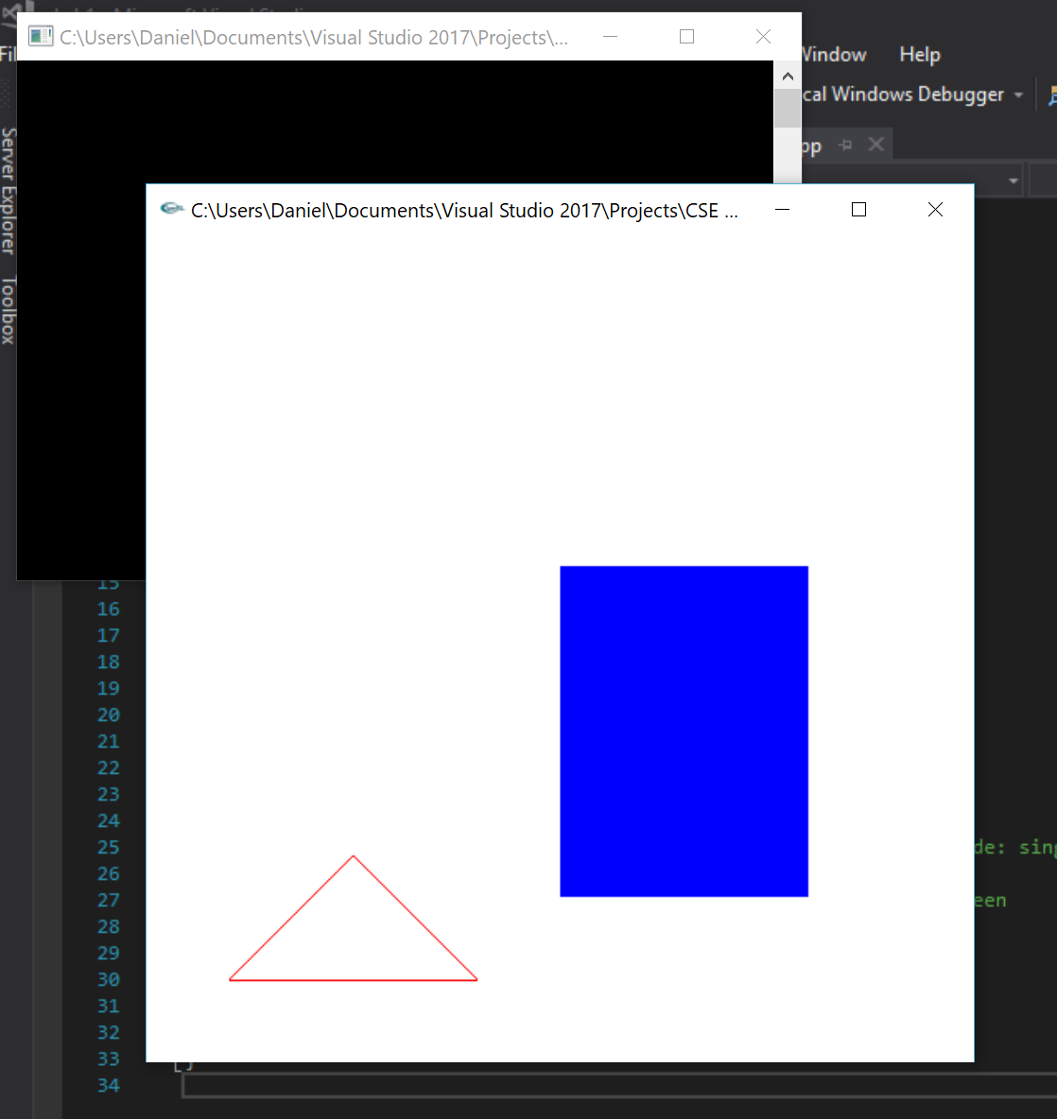

Modified draw.cpp to display a triangle and rectangle and changed the colors as well. Below is the modified code:

glColor3f(0.0, 0.0, 1.0); //blue rectangle

glRecti(250, 100, 400, 300); //draw rectangle

glColor3f(1.0, 0.0, 0.0); //red triangle

glBegin(GL_LINES); //start drawing triangle

glVertex2i(50, 50); //point 1

glVertex2i(125, 125); //point 1 -> point 2

glVertex2i(125, 125); //point 2

glVertex2i(200, 50); //point 2 -> point 3

glVertex2i(200, 50); //point 3

glVertex2i(50, 50); //point 3 -> point 1

glEnd(); //stop drawing

glFlush(); //send all output to screen

**Part 2:**

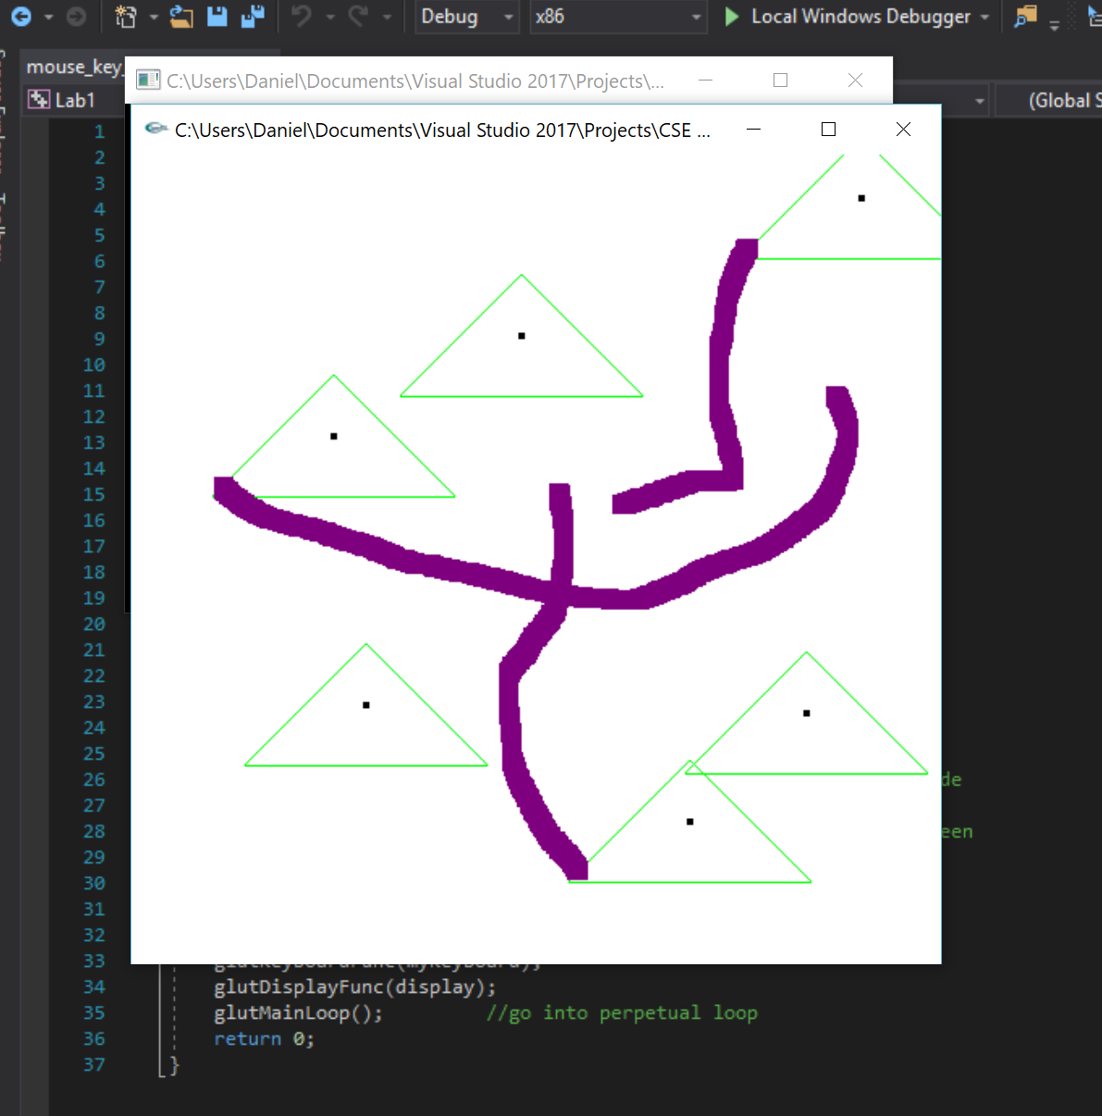

Modified mouse_key.cpp to create a triangle with a dot in the center on mouse click and trace purple squares when held. Below is the modified code:

void drawDot(int x, int y)

{

glColor3f(0.0, 0.0, 0.0);

glBegin(GL_POINTS);

glVertex2i(x + 75, y + 37); //draw a points

glEnd();

} //drawDot

void drawTriangle(int x, int y)

{

glColor3f(0.0, 1.0, 0.0);

glBegin(GL_LINES); //start drawing triangle

glVertex2i(x, y); //point 1

glVertex2i(x + 75, y + 75); //point 1 -> point 2

glVertex2i(x + 75, y + 75); //point 2

glVertex2i(x + 150, y); //point 2 -> point 3

glVertex2i(x + 150, y); //point 3

glVertex2i(x, y); //point 3 -> point 1

glEnd();

} //drawTriangle

void myMouse(int button, int state, int x, int y)

{

if (button == GLUT_LEFT_BUTTON && state == GLUT_DOWN)

{

drawDot(x, screenHeight - y);

drawTriangle(x, screenHeight - y);

}

glFlush(); //send all output to screen

}

void myMovedMouse(int mouseX, int mouseY)

{

GLint x = mouseX;

GLint y = screenHeight - mouseY;

GLint brushsize = 12;

glColor3f(0.5, 0.0, 0.5);

glRecti(x, y, x + brushsize, y + brushsize);

glFlush();

} //myMovedMouse

**Summary:**

The Lab is designed to familiarize ourselves with the basics of OpenGL through the creation of simple objects and performing basic actions using these objects. This assignment also helped learn how to input external .lib and .dll into Visual Studio for work at home. Each program worked as intended without error. The end result are programs that fulfill the guidelines of the assignment and as such feel my submission is worth 20 points.